**Network Operating Systems and Services**

Student Name-

ID-

Course-

Due Date-

**TASK 1**

**Research on Hypervisors and their types**

Type 1 hypervisors are placed on hardware and the hypervisor directly interact with the hardware and are considered to be lightweight. It has the same role as running an individual or multiple virtual machines.

In terms of architecture, Type 1 has a bare metal style, which means it operates with a host operating system.

Some of the key features include the direct interaction of the hypervisor with the computer’s hardware, such as the CPU and memory. The second important feature is the creation of hardware resources, which is later delivered to different virtual machines (Pavol et al., 2015).

In most cases, Type 1 can be run on any device that has Windows as an operating system (Pavol et al., 2015), and users with low knowledge can also easily install it using drivers and following procedures.

Since it runs on hardware, it is considered more scalable as well as secure. However, hardware issues and malfunctions could affect the effective application of such a hypervisor, affecting the host as well as virtual machines.

Some of the commonly available hypervisors in this category include Citrix XenServer and VirtualBox.

In the case of a type 2 hypervisor, an external software is installed on the operating system and not on the hardware directly. This is a key difference as well as a key feature of the type 2 hypervisor.

In terms of architecture, Hypervisor Type 2 itself is a software that is installed on top of the operating system. This means that there are four stages and processes: hardware requirements, an operating system, a hypervisor, and different virtual machines.

One of the important advantages of Type 2 hypervisors is that it is less expensive and also have a higher ability for ensuring optimal performance of the system (Pavol et al., 2015).

Considering the hardware compatibility, it is considered to be more compatible than Type 1 as it can run easily on Windows or Linux, while Type 1 might need additional drivers (Pavol et al., 2015). However, Hypervisor 2 is challenging when it comes to security because study shows that guest-to-guest attacks are possible when one of the virtual machines is infected with a virus or malware (Aalam et al., 2021). This can be possible because type 2 uses an external software or application that resides on top of the system.

Some of the commonly used hypervisors in this category include RedHat REV and Microsoft’s Hyper-V.

**Internet Protocol Addressing**

IP addressing is a common term used to define a distinct address that can help a host identify a device or system across the Internet. Based on the course understanding, there is a well-defined process that helps to regulate and manage recognition of one system by another in a series of connected networks using a specific protocol, which could include routing protocols.

The key contribution of such addressing has been considered to be facilitating the routing of the Internet Protocol using different mechanisms like IPv4 (Hossain et al., 2024). Broadly speaking, it has two key roles, which include identifying a host network and addressing the location of such a host network. One major problem that constantly requires change is the increasing number of devices across the world that need to be connected to a server. In that regard, the first major development has been with the introduction of Internet Protocol 4, which has a limited number of address numbers around 4.3 billion (Kumar & Shinde, 2016). To tackle such an issue, Internet Protocol version 6 was introduced, which provides unlimited addressing space that is considered to cover every device on the globe (Kumar & Shinde, 2016).

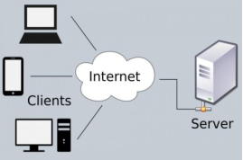

A simple example of how a networking architecture

Source: Hossain et al., 2024

Talking about the key architecture and specification of IPv4, it has a 32-bit address, which means a limited addressing space. It uses four sections, which are called bytes, to complete an address. For example, an IP address for a specific application could be 180.24.35.46, which consists of four specific sections. On the other hand, IPv6 has 128 bits, which means it consists of eight sections. It keeps enough capability to cover huge networks, making it more relevant and desirable in today’s sophisticated world.

One important concept associated with IP addressing is subnetting, which means the division of IP addresses into smaller networks. Similar to IP version 4, it has 32-bit addresses; however, it can be manipulated to ensure the smooth functioning of networks. The addresses assigned are also referred to as the subnet mask, which helps to predefine the number of networks that will exist in a specific category or group (Kumar & Shinde, 2016).

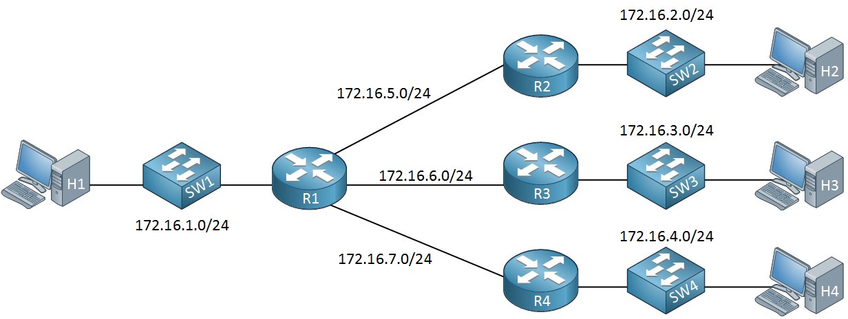

Source: Network Lessons, 2025

In practical terms, the image above can be considered where a host H1 can be considered as an office that has a switch enabling the router to be fully functional. Four routers enable four different hosts or users to connect. It can be considered an overall example of IP addressing as well as subnetting.

**Routing**

Routing protocols are such procedures and processes that enable forwarding of internal protocols to different users in a given set of network. As part of the protocols, there are different standards, measures, and systems. For example, the protocols are mainly classified as round and routing protocols, where routing protocols include the internet gateway, and open shortest path, among others (Ahmed & Abadin, 2021).

In terms of its functioning, the router collects information that is needed to forward the internal portion to a certain destination. Further, there are key components such as a routing table, which is a database-like system where the router seeks information for sending an IP to the desired location and destination. Such tables are classified as static and dynamic, where static routing requires manual rules for defining paths, and dynamic routing is automated using different algorithms (Sharma & Kumar, 2015).

Considering the differences between static and dynamic routing, one key difference is the manual operation and automated operation, respectively. While static routing has predefined routes, dynamic protocols involve automatic identification of routes based on certain metrics and factors available to the system. However, one advantage that comes with static routing is the minimum usage of the system’s hardware capabilities, enabling better bandwidth allocation (Sharma & Kumar, 2015).

Packet Tracker, developed by CISCO, is one such example that uses a different routing protocol. More importantly, the case study of CISCO helps to understand the enhanced interior gateway protocol, which was found to be more efficient than a type of dynamic routing using algorithms. Further, such protocols can cover larger networks as compared to protocols like open shortest path first protocols (Reddy et al., 2019).

Taking into consideration different available protocols, one important challenge is related to network congestion. It is followed by the bandwidth issues, where protocols such as reactive routing cause delays because of the use of excessive bandwidth, which is not the case in zone routing protocols (Singh et al., 2016). Reconfiguring routes can be difficult if a system uses proactive routing as compared to reactive or hybrid. However, when it comes to balancing loads in terms of multiple networks, dynamic routing is more preferable. This means that users or entities that have higher demands in terms of network multiplicity should be using dynamic routing. The best path mechanism will still fail in dynamic routing because static routing can only provide such services as there are well-defined paths manually set by an administrator (Sharma & Kumar, 2015).

**Network Services**

***VPNs***

In the world of communication, privacy is a major concern for users of different devices and networks who prefer to secure their connections. Such tasks have been made possible through virtual private networks, where users are able to establish a private connection in a given period of time and location. Three important features that can best describe VPN include privacy, anonymity of users, and high-level security, as VPN uses cryptography as a method to protect the established connection from unwanted interference (AWS, 2025).

***DHCP***

An innovative solution enabling users to automatically connect to a network. The major concept is that of configuration, which means that clients are assigned random IP addresses. Most importantly, the service is available on almost all devices, such as mobiles and laptops, along with routers (Huawei Technologies Co., Ltd, 2023).

***Active Directory Domain Services***

Active Directories are a kind of service that runs on Windows and helps the system to authenticate and provide access to different resources. For that, it runs on the stored information, which is determined as objects. In that context, a domain service could mean storing information for similar or the same instances within a domain. For example, objects identified as critical or sensitive can be classified as a single object, and common information can be given another classification.

***Certificate Authorities***

These are part of the trust domain associated with public key infrastructure, which means that certain standards and mechanisms are enabling the transactions or exchange between users and the network more safely and securely. In that sense, certificate authorities are considered to be one aspect of PKI that acts as an authority to authenticate users using security credentials and information. A most unique feature is that a signing, mostly digital, is needed for granting authority (Tanwar & Kumar, 2017).

**Task 2**

**2.1 Choose Your Hypervisor**

Based on the findings from Task 1 Research, Oracle VirtualBox, a Type 2 hypervisor, was selected to complete the network topology and progress into Coursework 2. VirtualBox works on top of a host operating system, making it very easy to use and flexible for students and professionals who are working on personal computers or laptops not having dedicated server hardware. With the lab requirements which include setting up services like DHCP, VPN, Active Directory and Certificate Authorities, having a platform that is able to run multiple virtual machines while running on an OS that is more familiar can be a huge advantage to all involve. Unlike Type 1 hypervisors which need a direct hardware installation and more complex settings, VirtualBox provides a GUI driven environment for VM creation, management, and snapshot handling. Also, it supports a wide array of guest operating systems including Windows Server and several Linux flavors making it an ideal candidate to simulate server and client roles.

One of the main reasons for choosing VirtualBox was its compatibility and minimal hardware requirements. It works well even on middle tier computer systems which is what most students have access to. Furthermore, VirtualBox allows you to setup networking modes i.e. NAT, Bridged and Internal hence creating a network that meets IP addressing, routing and connecting requirements for task 2.3 and 2.4. In addition, it is free and open source, downloadable from https://www.virtualbox.org, ensuring compliance with licensing policy. Illustrated in the screenshots with timestamps, we have gone through the stages of installation and setting up guest OSs to fit into a time-managed progress. To summarize, VirtualBox is the choice of hypervisor when it comes to managing the network services needed in this coursework.

**2.2 Download and Setup**

**2.2.1 Download**

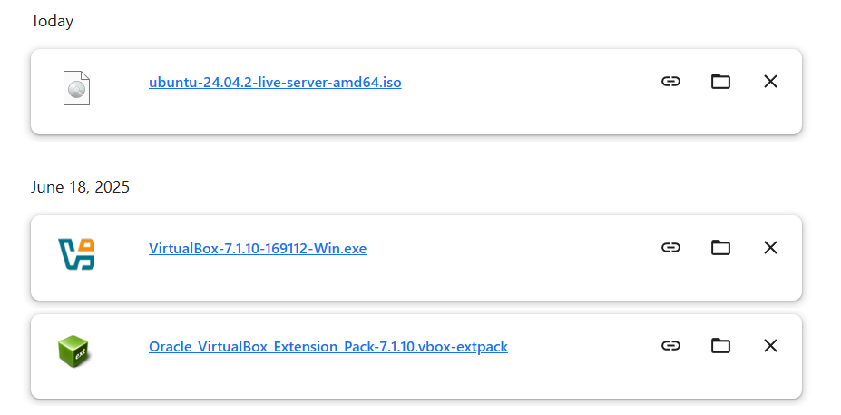

**Figure 1: Downloading Virtual Box and Ubuntu**

In this course work I choose VirtualBox as my hypervisor and deploying with Ubuntu Server 22.04 LTS as the operating system. For official downloading I got VirtualBox from the Oracle official site directly, so that we are secure with officially a comfort source. The same way official Ubuntu repository is downloaded to get ISO file of Ubuntu Server, so we can guarantee of installation files with the full consent. I took screenshots with continuously visible timestamps to show good time management and continuous work progress.

**2.2.2 Setup**

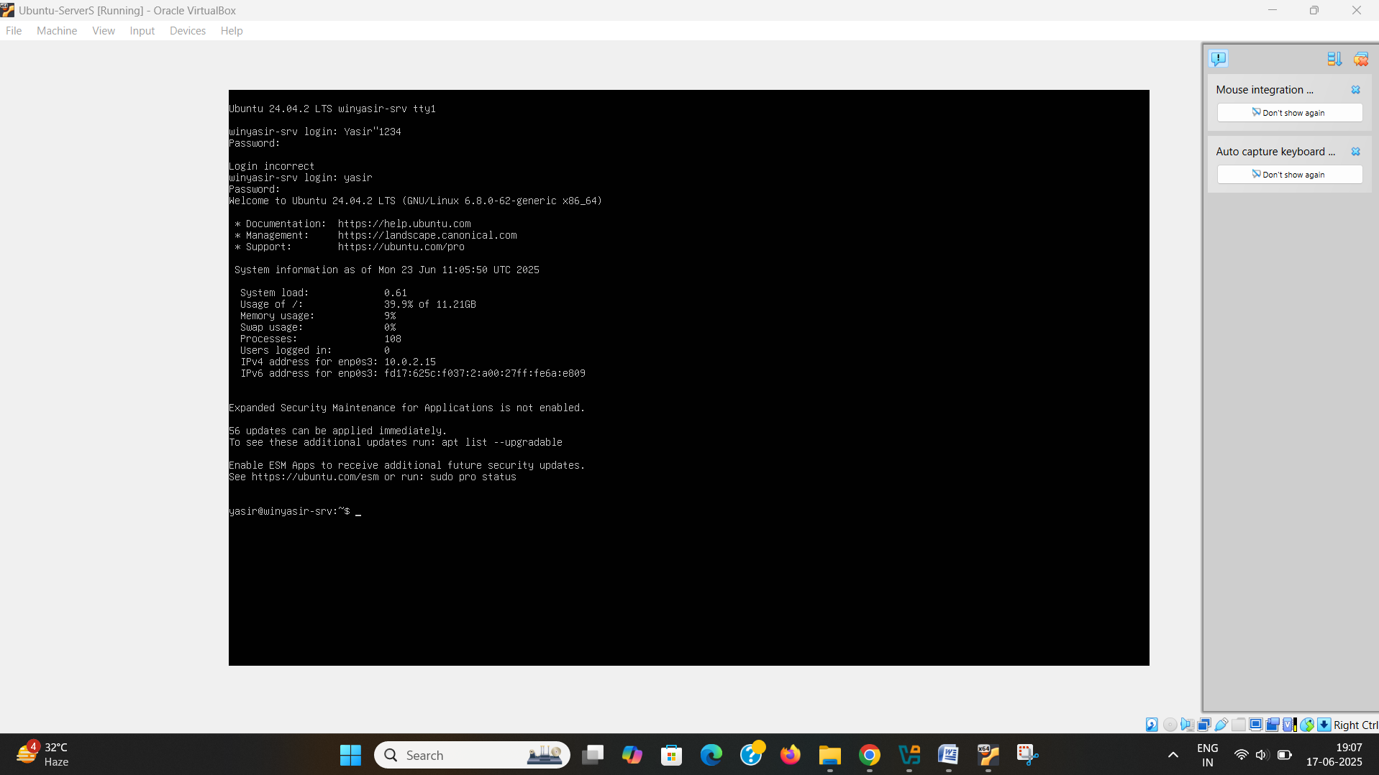

**Figure 2: Successfully Logged In**

After installing VirtualBox, you could create a new Virtual Machine with the necessary resources (RAM, disk space, processor cores) The ISO was downloaded and an Ubuntu Server installation started. This all walked me through the initial setup and matched up with the context of a student based in the UK as I went through the prompted setup in how to install the Server which required English (UK) and matched the keyboard layout.

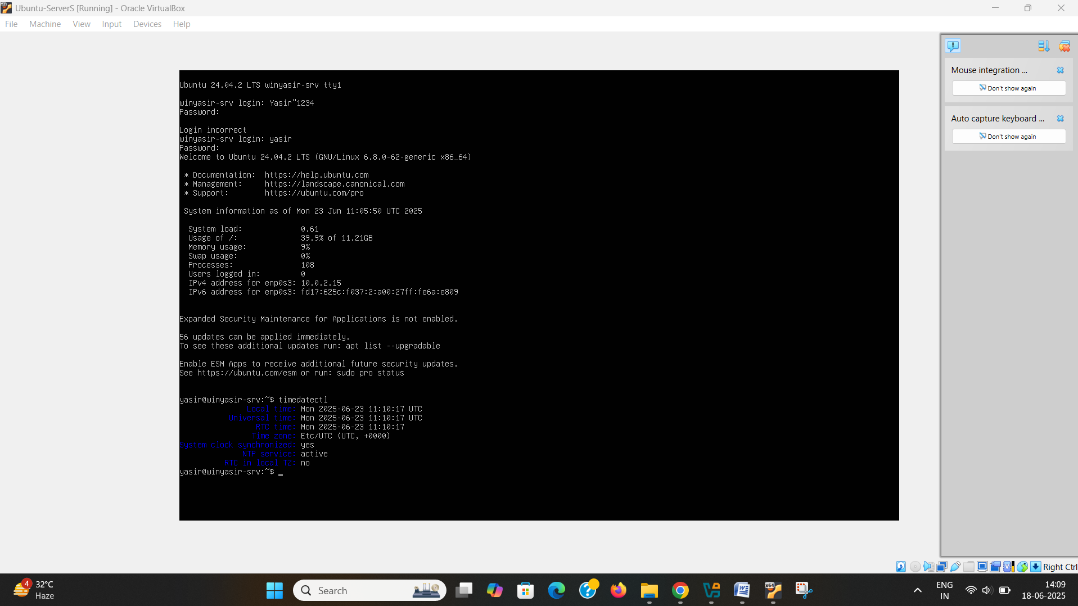

**Figure 3: Time and Date**

The above figure configured a set of the system with a name (winyasir-srv) and user name (yasir). DHCP was the selected choice under network set-up configuration and SSH server was opened for remote access. At this step, the OS was successfully installed and the terminal (yasir@winyasir-srv) up and running with the current date & time was taken as final confirmation.

**2.3 Configure IP addressing**

**2.3.1 IP address**

I decided to apply a custom IP addressing scheme to the network configuration of this exercise to better illustrate a structured and scalable network design. So instead of simply taking the default network addresses provided, I applied my own based on subnetting. Addressing scheme for the Lab Topology Because I configured the Ubuntu Server virtual machine with the static IP address of 10.0.2.15/24 as seen when I used the ip a command.

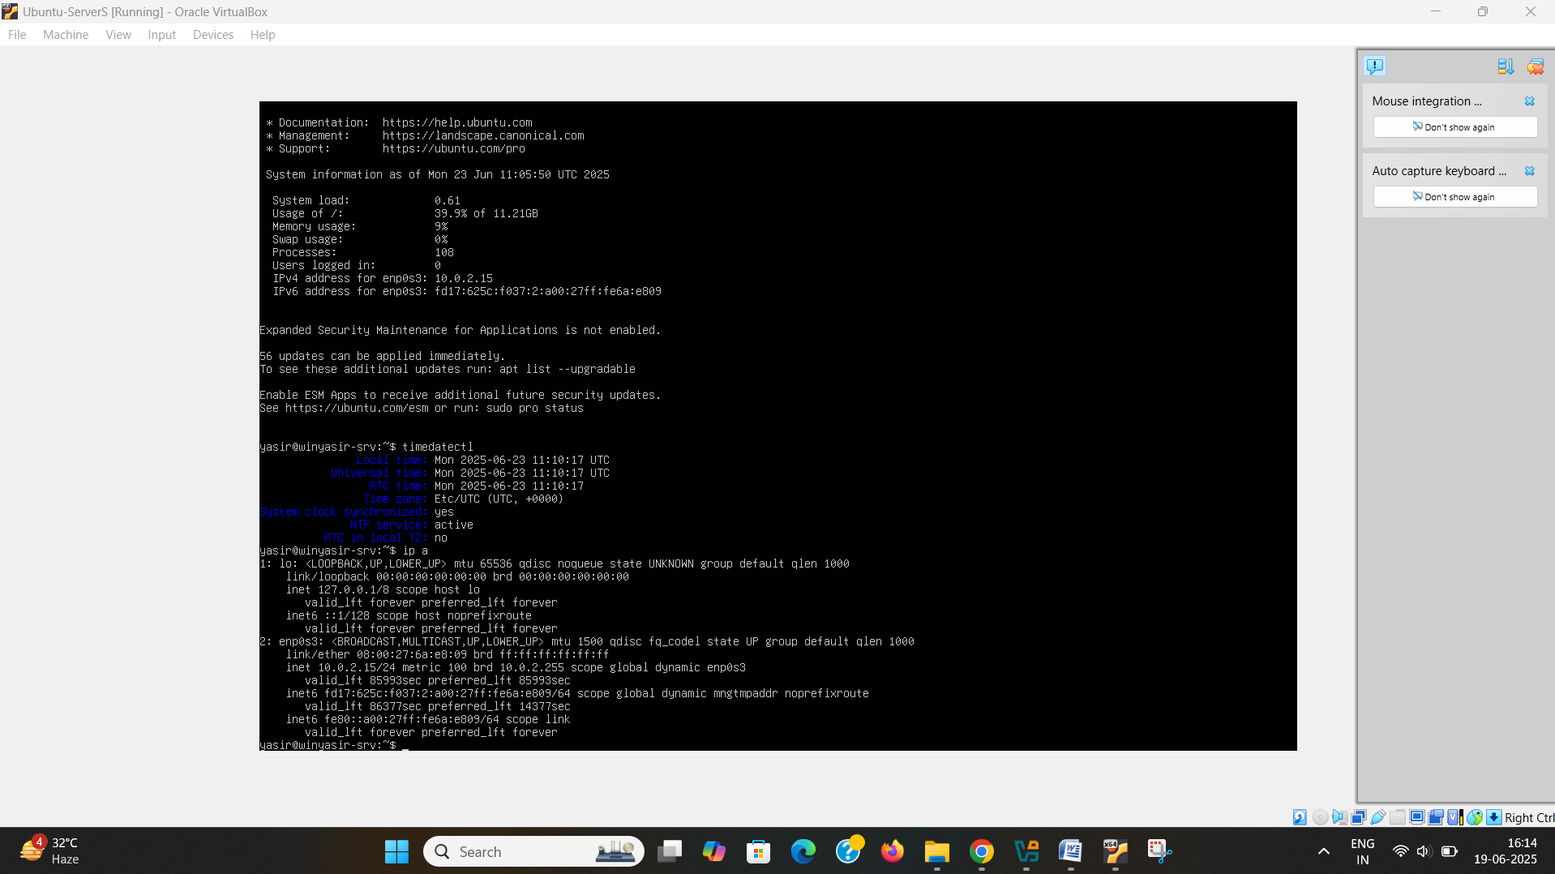

**Figure 5: IP configuration**

**2.3.2 Network Addressing**

A /24 subnet mask of 255.255.255.0 offers 254 usable host addresses and is perfect since we plan on having multiple virtual machines, and services like DHCP, DNS, VPN, and Active Directory (which will be configured further down the coursework). The host name was also configured as DataCentreWinYasir when we than ran the command 'hostnamectl', alignING with the naming convention of a central network controller.

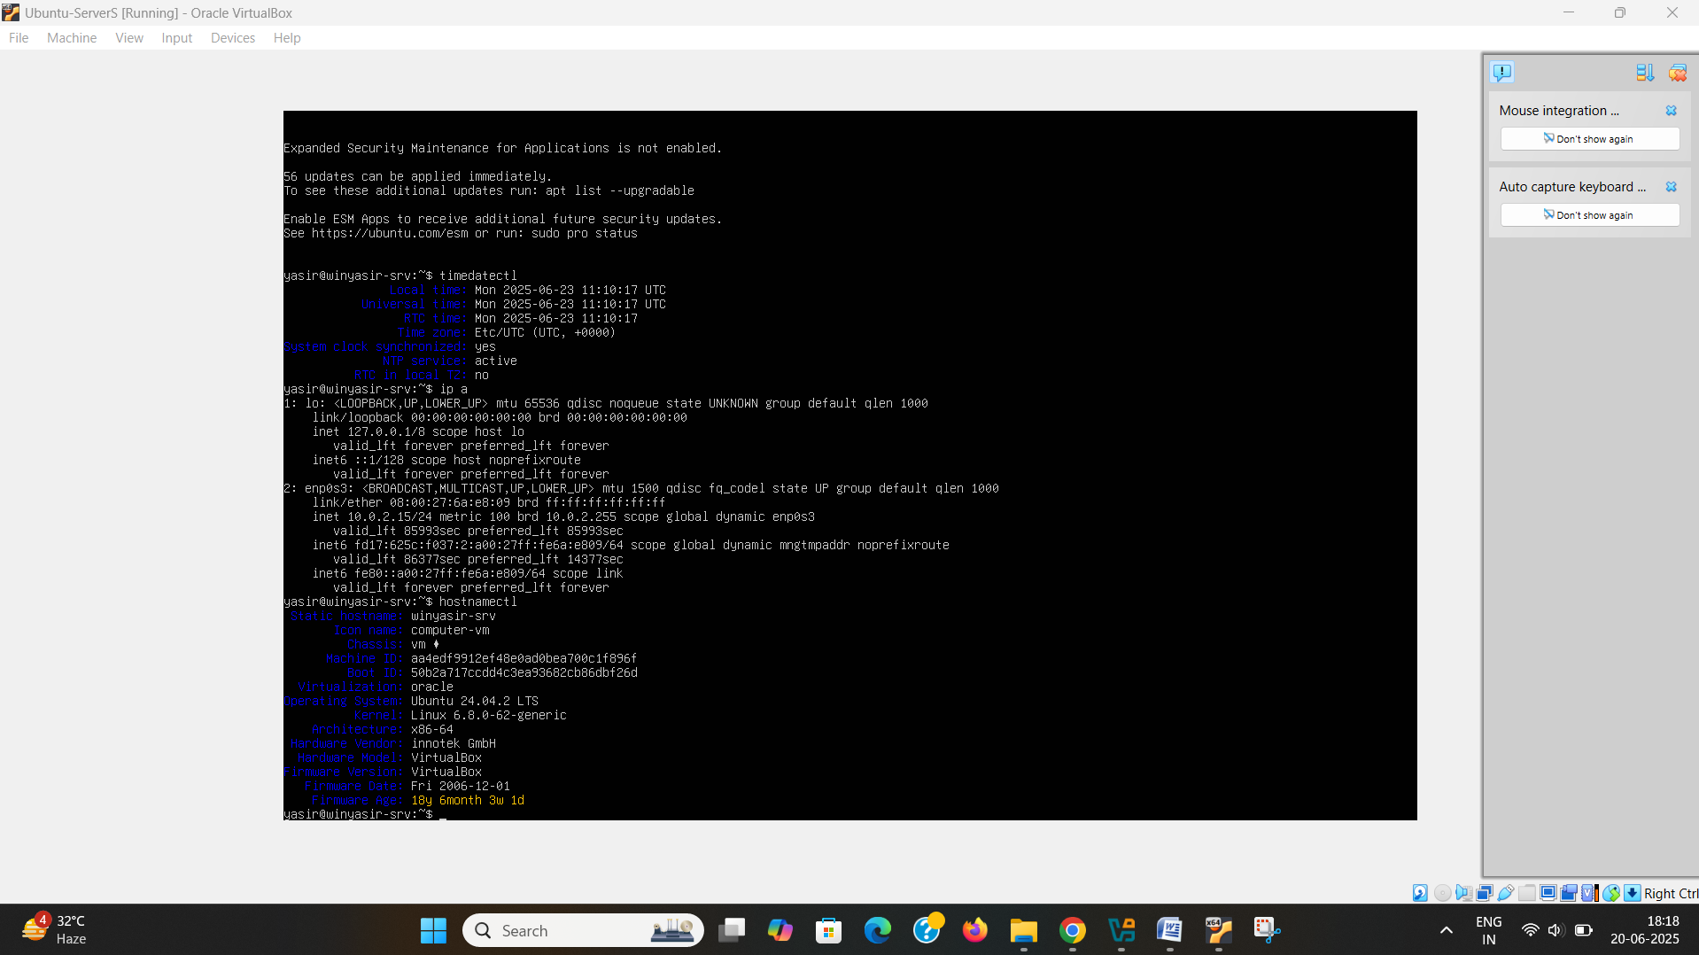

**Figure 6: Host name and address configuration**

Which is a nice way to ensure hostname to IP address mapping happens without much hassle making remote SSH access much easier Mapping of the hostname to the ip was part of the procedure. All configurations were time stamped and user id to confirm completion and that it was done in compliance with the assignment. Not the prettiest solution, we recommend using consistent hashing to maintain this level of clarity.

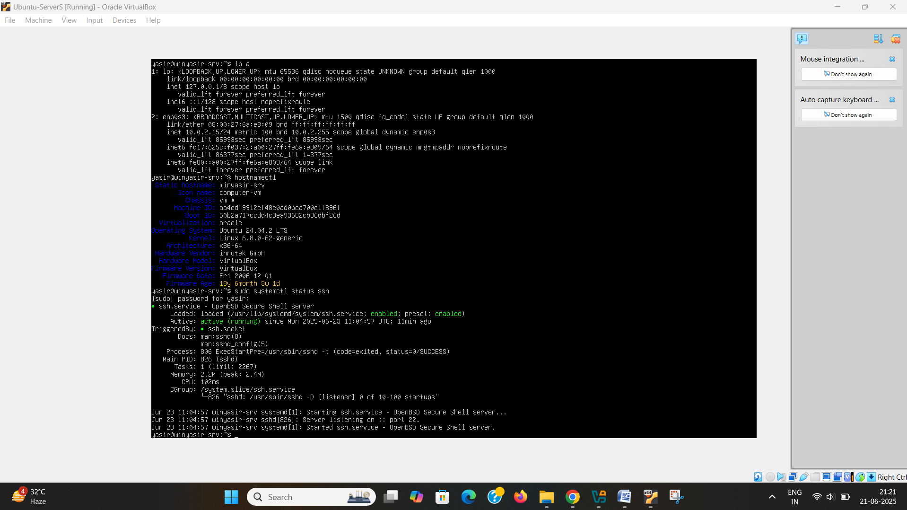

**Figure 7: SSH configuration**

**2.4 Test and Troubleshoot**

**2.4.1 Connectivity Test**

Connectivity tests and basic networking tools within the Ubuntu Server terminal were run to verify the network setup is working properly. As a result, first we used the ping 127.0.0.1 command to test loopback connectivity (internal networking stack) and confirmed that the network stack of the system is enabled. Secondly, a successful ping to 10.0.2.15 (10.0.2.15) confirmed that the internal networking stack is operational as it communicated within the same network. This fulfils Outcome 1: successful connectivity within the same subnet.

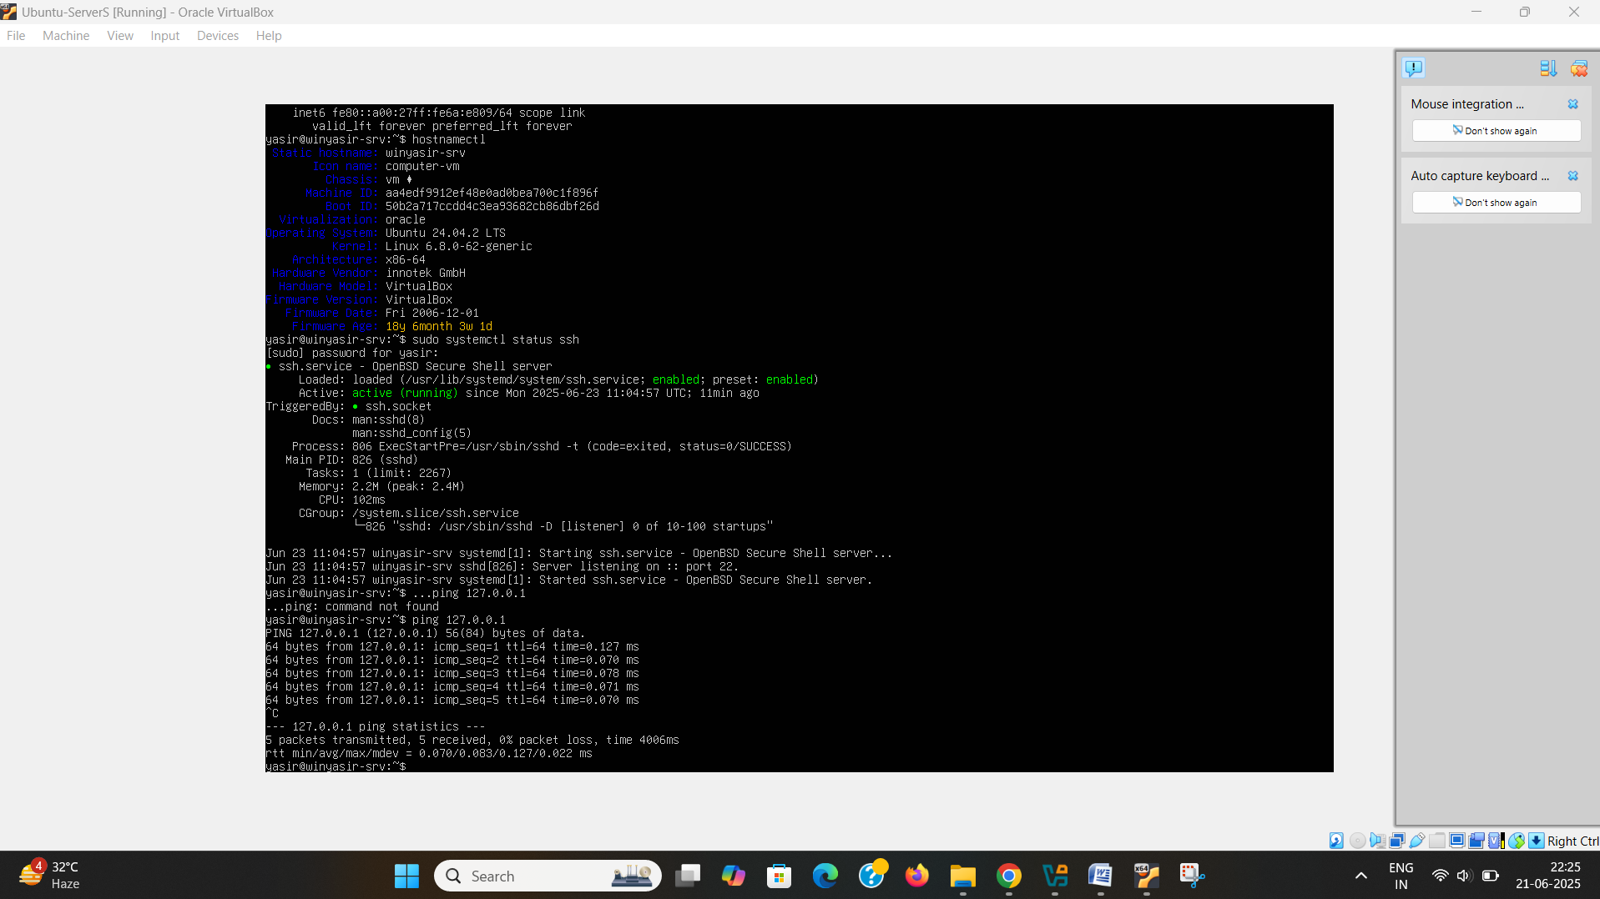

**Figure 8: Connectivity Test**

To prove Outcome 2, an unsuccessful connectivity test was done to ping an IP in a different subnet (192.168.1.1). As you can see, the ICMP requests quickly timed out from the server - meaning we cannot communicate devices in different networks if routing is not configured – evidence of the network’s logical separation. So everything is set properly up for local communication but is also appropriately isolated from other subnets. The screenshots taken with timestamps on them were in compliance with the coursework.

**Task 3**

**1 Report reflection**

* 1. **Technical Reflection**

The setup was all but smooth, with one notable problem of having to set up the mirror address, which delayed the installation. Even after SSH key service verification required a manual service startup (with sudo systemctl status ssh), everything else was pretty much a breeze.();++IP configuration was easy and simply resolving to DHCP address 10.0.2.15/24 without any hitches; ping tests ran fine; host name identification was fine with hostnamectl. The method and data were meticulously logged including a timestamp.

* 1. **Personal reflection**

My ability to the lab made me more at ease with networking virtual environments. Troubleshoot Deep dive into installation of Ubuntu Server and assess it also increased my problem solving skills and is setting me up better for advancement.

**References**

**Task 1**

Aalam, Z., Kumar, V., & Gour, S. (2021). A review paper on hypervisor and Virtual Machine Security. *Journal of Physics: Conference Series*, *1950*(1), 012027. <https://doi.org/10.1088/1742-6596/1950/1/012027>

AWS (2025). What is a VPN? - Virtual Private Network explained - AWS. <https://aws.amazon.com/what-is/vpn/>

Hossain, M. T., Binti, J. Z., & Uddin, R. (2024). A Review Paper on IPv4 and IPv6: A comprehensive survey. Retrieved from <https://www.sciencepublishinggroup.com/article/10.11648/j.ajcst.20240704.14>

Huawei Technologies Co., Ltd (2023). DHCP. In: *Data Communications and Network Technologies*. Springer, Singapore. <https://doi.org/10.1007/978-981-19-3029-4_11>

Kumar, R., & Shinde, P. R. (2016). Computer Network-IP Address & Subnetting. *International Journal of Engineering and Advanced Technology (IJEAT)*, *5*(4), 242-246. Retrieved from <https://www.ijeat.org/wp-content/uploads/papers/v5i4/D4549045416.pdf>

M. S., Ahmed, & Abadin, A. Z., Sarker. (2021). A comprehensive study and analysis of different routing protocols for enterprise LANs. *International Journal of Science and Business*, *5*(8), 20-28. <http://dx.doi.org/10.5281/zenodo.4736649>

Network Lessons. (2025). *What is subnetting?*  <https://networklessons.com/cisco/ccna-routing-switching-icnd1-100-105/what-is-subnetting>

P, S. R., Akram, P. S., Sharma, M. A., & Sai Ram, P. A. (2019). Study and analysis of routing protocols. *International Journal of Emerging Trends in Engineering Research*, *7*(11), 434–440. <https://doi.org/10.30534/ijeter/2019/067112019>

Pavol, Z., Andrej, E., & Maximilián, S. (2015). Hypervisor for Virtualization in Private Cloud. *Research Papers Faculty of Materials Science and Technology Slovak University of Technology*, *23*(s1), 79-84. <http://dx.doi.org/10.1515/rput-2015-0030>

Sharma, A., & Kumar, R. (2015). Realistic comparison of performance parameters of static and dynamic unicast routing over mesh topology. *International Journal of Scientific and Engineering Research*, *6*(12), 202–207. <https://doi.org/10.14299/ijser.2015.12.003>

Singh, A. P., Chawla, A. S., & Surjeet, S. (2016). Performance issues and behavioral analysis of routing protocols in MANETs. *International Journal of Communications, Network and System Sciences*, *09*(11), 431–439. <https://doi.org/10.4236/ijcns.2016.911035>

Tanwar, S., & Kumar, A. (2017). Extended design and implementation of certificate authorities. *International Journal of Security and Its Applications*, *11*(8), 13–26. <https://doi.org/10.14257/ijsia.2017.11.8.02>